**A PROJECT REPORT**

**on**

# “Customer Behaviour Analysis”

**Submitted to**

# KIIT Deemed to be University

**In Partial Fulfillment of the Requirement for the Award of BACHELOR’S DEGREE IN**

**COMPUTER SCIENCE AND ENGINEERING**

**BY**

**Bidisha B. Muduli 2105537**

**Tanishq Chaurasia 2105587**

**UNDER THE GUIDANCE OF**

**Mr. Sovan Kumar Sahoo**



KIIT Deemed to be University

School of Computer Engineering Bhubaneswar, ODISHA 751024



CERTIFICATE

This is to certify that the project entitled “Customer Behaviour Analysis” submitted by

| Bidisha B. Muduli | 2105537 |
| --- | --- |
| Tanishq Chaurasia | 2105587 |
|  |  |
|  |  |

is a record of bonafide work carried out by them, in the partial fulfillment of the requirement for the award of Degree of Bachelor of Engineering (Computer Science & Engineering) at KIIT Deemed to be University, Bhubaneswar. This work is done during the year 2023-2024 (Spring), under our guidance.

Date: 03/04/24

(Mr. Sovan Kumar Sahoo)

Project Guide

# Acknowledgment

|  |  |
| --- | --- |
|  |  |
|  |  |

We are profoundly grateful to Mr. Sovan Kumar Sahoo for his invaluable expertise, steadfast guidance, and unwavering encouragement throughout every stage of this project's journey, from its inception to its successful completion.

From providing expert advice on methodology and techniques to offering constructive feedback and encouragement during challenging times, Mr. Sahoo's dedication and commitment to our project have been truly exemplary. His unwavering belief in our abilities and his willingness to go above and beyond to ensure our success have been a constant source of inspiration and motivation.

We are deeply grateful for Mr. Sahoo's unwavering commitment, patience, and support throughout the duration of this project. His guidance has been invaluable in shaping our understanding, refining our approach, and ultimately delivering a project that meets and exceeds its targets and expectations.

In conclusion, we extend our heartfelt gratitude to Mr. Sovan Kumar Sahoo for his exceptional mentorship and leadership, without which this project would not have been possible. We are truly fortunate to have had the opportunity to learn from his expertise and guidance, and we look forward to continuing our journey under his mentorship in the future.

| Bidisha B. Muduli  Tanishq Chaurasia |
| --- |

|  |
| --- |
|  |

# ABSTRACT

Customer Behaviour Analysis is a crucial process for modern businesses seeking to gain a deeper understanding of their clientele. In this report, we delve into the realm of customer data analysis using Python, focusing on the utilization of a CSV dataset. Our objective is to provide businesses with actionable insights into the diverse personas that comprise their customer base.

Through the implementation of Python programming, we leverage the power of data science techniques to explore, preprocess, segment, and analyze customer data. Our methodology involves data cleaning, segmentation using clustering algorithms, and visualization to uncover distinct customer personas.

By dissecting customer attributes such as demographics, purchasing behavior, and preferences, our analysis aims to unveil patterns and trends that enable businesses to tailor their products, services, and marketing strategies to better align with the needs and desires of their target audience.

Through this report, we aim to equip businesses with the knowledge and tools necessary to conduct comprehensive customer behaviour analysis, thereby facilitating informed decision-making and fostering stronger connections with their clientele.

Contents

| S.No. | Topic | | | | | | | Pg No. |
| --- | --- | --- | --- | --- | --- | --- | --- | --- |
| 1 | Introduction | | | | | | | 7 |
| 2 | Basic Concepts/ Literature Review | | | | | | | 8-14 |
|  | 2.1 | Introduction | | | | | | 9 |
|  | 2.2 | Context and rationale | | | | | | 10 |
|  | 2.3 | Objectives & Scope | | | | | | 11 |
|  | 2.4 | Vision | | | | | | 12 |
|  | 2.5 | Impact | | | | | | 13 |
|  | 2.6 | Challenges | | | | | | 13 |
|  | 2.7 | Conclusion | | | | | | 14 |
| 3 | Data Set Used | | | | | | | 15-16 |
|  | 3.1 | Problem Statement | | | | | | 15 |
|  | 3.2 | Column Information | | | | | | 16 |
|  | 3.3 | Target | | | | | | 16 |
| 4 | Experimental Results | | | | | | | 17-24 |
| 5 | Standards Adopted | | | | | | | 25-27 |
|  | 5.1 | Design Standards | | | | | | 25 |
|  | 5.2 | Coding Standards | | | | | | 26 |
|  | 5.3 | Testing Standards | | | | | | 27 |
| 6 | Conclusion & Future Scope | | | | | | | 28-29 |
|  | 6.1 | Future Scope | | | | | | 28 |
|  | 6.2 | Conclusion | | | | | | 29 |
| 7 | References | | | | | | | 30 |

List of Figures

1. Frequency of Each Category in the TotalAcceptedCmp Variable

2. How Education Impacts on Expenses

3.How Marital Status Impacts on Expenses

4. How Kids Impacts on Expenses

5. How TotalAcceptedCmp impacts on Expenses

6. How NumTotalPurchase impacts on Expenses

7. How Days Engaged Impacts on Expenses

8. How Age Impacts on Expenses

9. Finding the Correlation

10. The Elbow Method

11. Scatterplot with Cluster Kmeans

12. A 3-D Projection of Data in the Reduced Dimension

13. The Plot of Clusters

Chapter 1 Introduction

In today's hyper-competitive business landscape, understanding customers is paramount to success. Customer Behaviour Analysis serves as a cornerstone for businesses striving to cultivate meaningful relationships with their clientele. By dissecting customer data and discerning underlying patterns, businesses can tailor their products, services, and marketing strategies to resonate more effectively with their target audience.

This report embarks on a journey into the realm of customer data analysis, leveraging the versatility of Python programming and the accessibility of CSV datasets. Our aim is to provide businesses with actionable insights into the diverse personas that comprise their customer base.

As businesses strive to adapt to evolving consumer preferences and market dynamics, the significance of customer-centric strategies cannot be overstated. By delving into the intricacies of customer data, we endeavor to equip businesses with the tools and methodologies necessary to conduct comprehensive customer behaviour analysis.

Through the systematic exploration of customer attributes such as demographics, purchasing behavior, and preferences, this report seeks to unravel the complex tapestry of customer personas. By uncovering latent insights buried within the data, businesses can gain a competitive edge by tailoring their offerings to better meet the needs and desires of their target audience.

As we embark on this journey, we invite readers to delve into the intricacies of customer data analysis, exploring the potential for innovation and growth that lies within. By harnessing the power of data science techniques, businesses can unlock a deeper understanding of their customers, paving the way for more meaningful interactions and sustained success in today's dynamic marketplace.



Chapter 2

Basic Concepts/ Literature Review

### Introduction

In the contemporary business landscape, where customer preferences shift rapidly and competition intensifies, understanding the intricacies of consumer behavior has become indispensable for enterprises aiming to thrive. Customer Behaviour Analysis stands at the forefront of this endeavor, offering a nuanced perspective on the diverse array of individuals that comprise a company's customer base. By dissecting customer data with precision and insight, businesses can gain invaluable insights into the needs, preferences, and behaviors of their clientele, thereby fostering stronger connections and driving strategic decision-making.

In this report, we embark on a journey into the realm of customer data analysis using Python, with a focus on harnessing the wealth of information stored within CSV datasets. Our objective is clear: to empower businesses with the tools and methodologies necessary to conduct comprehensive customer behaviour analyses, unlocking actionable insights that can inform product development, marketing strategies, and customer engagement initiatives.

The significance of customer-centric approaches in today's business landscape cannot be overstated. As businesses strive to differentiate themselves in crowded markets and deliver personalized experiences to their customers, the ability to discern patterns and extract meaningful insights from customer data emerges as a strategic imperative. Through the lens of data science techniques and Python programming, we aim to demystify the process of customer analysis, making it accessible and actionable for businesses of all sizes and industries.

By systematically exploring customer attributes such as demographics, purchasing behavior, and psychographic characteristics, this report seeks to unveil the diverse personas that populate a company's customer base. Through the application of clustering algorithms, visualization techniques, and advanced analytics, we endeavor to shed light on the nuanced preferences and motivations that drive consumer decision-making.

As we delve into the intricacies of customer data analysis, we invite readers to embark on a journey of discovery, exploring the untapped potential that lies within their own customer datasets. By harnessing the power of data-driven insights, businesses can unlock new avenues for growth, innovation, and competitive advantage, positioning themselves at the forefront of a rapidly evolving marketplace.

### Context and Rationale

In today's dynamic business environment, understanding customers on a deeper level is crucial for success. Customer Behaviour Analysis allows businesses to go beyond demographics, uncovering unique preferences and behaviors that drive consumer decisions.

This analysis enables businesses to:

1. Tailor products, services, and marketing strategies to better meet customer needs.

2. Identify opportunities for improvement by analyzing customer feedback and behavior.

3. Stay agile by anticipating shifts in consumer preferences and market trends.

Ultimately, Customer Behaviour Analysis empowers businesses to foster stronger connections with customers and maintain a competitive edge in the marketplace.

### Objectives and Scope

Objective:

The primary objective of this project is to conduct a comprehensive Customer Behaviour Analysis using Python programming techniques and a CSV dataset. The analysis aims to provide actionable insights into the diverse personas within a company's customer base, enabling informed decision-making and strategic planning. Specific objectives include:

1. Explore and preprocess the customer dataset to ensure data quality and consistency.

2. Segment customers based on shared characteristics and preferences using clustering algorithms.

3. Analyze customer segments to uncover patterns, preferences, and behaviors.

4. Visualize the results to present findings effectively and facilitate interpretation.

5. Provide recommendations for product modifications, marketing strategies, and customer engagement initiatives based on the analysis.

Scope:

The scope of this project encompasses the following aspects:

1. Utilization of Python programming language for data analysis and visualization.

2. Analysis of customer data sourced from a CSV dataset, focusing on attributes such as demographics, purchasing behavior, and preferences.

3. Implementation of clustering algorithms to segment customers into distinct personas.

4. Interpretation of analysis results to gain insights into customer behavior and preferences.

5. Presentation of findings through visualization techniques to facilitate understanding and decision-making.

6. Recommendations for actionable strategies based on the analysis to improve product offerings, marketing campaigns, and customer engagement initiatives.

The project scope is limited to the analysis of customer data within the provided dataset and does not extend to real-time data collection or external data sources. Additionally, the recommendations provided are based on the analysis results and may require further validation or testing in a real-world business context.

### Vision

Our vision is to equip businesses with actionable insights derived from Customer Behaviour Analysis, enabling them to forge deeper connections with their customers and drive sustainable growth. Through advanced data analysis techniques and Python programming, we aim to unravel customer preferences, behaviors, and motivations, fostering a culture of customer-centric decision-making. Ultimately, we seek to empower businesses to anticipate customer needs, deliver personalized experiences, and build lasting relationships in today's dynamic marketplace.

### Impact

The impact of this project extends across various facets of business operations, with the potential to drive significant value and transformation. Key impacts include:

1. Enhanced Customer Understanding: By conducting Customer Behaviour Analysis, businesses gain a deeper understanding of their customers' preferences, behaviors, and motivations. This knowledge allows for more targeted product development, marketing strategies, and customer engagement initiatives, ultimately leading to improved customer satisfaction and loyalty.

2. Informed Decision-Making: The insights derived from the analysis enable businesses to make data-driven decisions across various departments, from product management to marketing and sales. This informed decision-making process ensures that resources are allocated effectively and strategies are aligned with customer needs and market trends.

3. Competitive Advantage: Businesses that leverage Customer Behaviour Analysis gain a competitive edge by offering tailored solutions that resonate with their target audience. By differentiating themselves through personalized experiences and targeted messaging, they can attract and retain customers in a crowded marketplace.

4. Optimized Resource Allocation: Understanding customer preferences allows businesses to allocate resources more efficiently, focusing on initiatives that are most likely to yield positive outcomes. This optimization of resources leads to improved ROI and overall business performance.

5. Long-Term Growth: By building stronger relationships with customers and continuously adapting to their evolving needs, businesses set themselves up for sustainable growth. Customer loyalty and advocacy contribute to repeat business and positive word-of-mouth, driving long-term success.

6. Cultural Shift: Embracing a customer-centric approach fosters a cultural shift within organizations, where customer needs and feedback are prioritized in decision-making processes. This customer-centric culture permeates throughout the organization, leading to improved employee satisfaction and alignment with business objectives.

Overall, the impact of Customer Behaviour Analysis is multifaceted, touching upon aspects of customer relationships, business strategy, and organizational culture. By harnessing the power of data-driven insights, businesses can unlock new opportunities for growth and success in today's competitive business landscape.

### Challenges

While Customer Behaviour Analysis offers numerous benefits, it also presents several challenges that businesses may encounter during implementation. These challenges include:

1. Data Quality and Availability: Obtaining high-quality and comprehensive customer data can be challenging, especially when dealing with disparate data sources or incomplete datasets. Ensuring data accuracy, consistency, and relevance is crucial for meaningful analysis.

2. Data Privacy and Compliance: Adhering to data privacy regulations such as GDPR or CCPA while handling customer data poses a significant challenge. Businesses must ensure that they have the necessary consent to collect and analyze customer data and implement robust security measures to protect sensitive information.

3. Data Integration and Management: Integrating data from multiple sources and formats can be complex and time-consuming. Businesses may struggle with data silos, incompatible systems, and outdated processes, hindering the seamless flow of information required for effective analysis.

4. Algorithm Selection and Interpretation: Choosing the appropriate clustering algorithms and parameters for Customer Behaviour Analysis requires careful consideration. Businesses may face challenges in selecting the most suitable algorithms for their specific dataset and interpreting the results accurately.

5. Overcoming Bias and Assumptions: Analyzing customer data may involve inherent biases and assumptions that can influence the outcomes of the analysis. Businesses must be vigilant in recognizing and mitigating these biases to ensure the accuracy and reliability of the insights generated.

6. Resource Constraints: Conducting comprehensive Customer Behaviour Analysis requires significant resources in terms of time, expertise, and technology infrastructure. Small businesses or those with limited resources may struggle to allocate the necessary resources for conducting robust analysis.

7. Change Management: Implementing insights derived from Customer Behaviour Analysis may require organizational changes, such as modifying product offerings, marketing strategies, or customer service processes. Businesses may encounter resistance to change from employees or stakeholders, necessitating effective change management strategies.

8. Measuring Impact and ROI: Evaluating the effectiveness and return on investment of Customer Behaviour Analysis initiatives can be challenging. Businesses need to establish clear metrics and benchmarks to track the impact of analysis efforts and justify ongoing investment in data analysis capabilities.

Addressing these challenges requires a holistic approach, encompassing data governance, technology infrastructure, organizational alignment, and ongoing learning and adaptation. By proactively addressing these challenges, businesses can unlock the full potential of Customer Behaviour Analysis and drive meaningful results for their organization.

### Conclusion

In conclusion, Customer Behaviour Analysis represents a powerful tool for businesses seeking to deepen their understanding of their customers and drive strategic decision-making. Through the systematic exploration of customer data using Python programming techniques and advanced analytics, businesses can uncover valuable insights into customer preferences, behaviors, and motivations.

Despite the challenges inherent in conducting Customer Behaviour Analysis, the potential benefits are significant. By leveraging insights derived from analysis efforts, businesses can tailor their products, services, and marketing strategies to better meet the needs and desires of their target audience. This customer-centric approach not only fosters stronger relationships with customers but also positions businesses for long-term growth and success in today's competitive marketplace.

As we look to the future, the importance of Customer Behaviour Analysis will only continue to grow. With advancements in technology, data science, and artificial intelligence, businesses have unprecedented opportunities to delve deeper into customer data and extract meaningful insights that drive innovation and differentiation.

In embracing the principles of customer-centricity and data-driven decision-making, businesses can unlock new opportunities for growth, enhance customer experiences, and build sustainable competitive advantage. By prioritizing Customer Behaviour Analysis as a strategic imperative, businesses can navigate the complexities of the modern business landscape with confidence and clarity, ultimately achieving their goals and aspirations in the digital age.

Chapter 3

**Data Set Used**

**Problem Statement :**

Customer Behaviour Analysis is a detailed analysis of a company’s ideal customers. It helps a business to better understand its customers and makes it easier for them to modify products according to the specific needs, behaviors and concerns of different types of customers.

Customer behaviour analysis helps a business to modify its product based on its target customers from different types of customer segments.

For example, instead of spending money to market a new product to every customer in the company’s database, a company can analyze which customer segment is most likely to buy the product and then market the product only on that particular segment.

### Column Information :

#### People : -

* ID: Customer's unique identifier
* Year_Birth: Customer's birth year
* Education: Customer's education level
* Marital_Status: Customer's marital status
* Income: Customer's yearly household income
* Kidhome: Number of children in customer's household
* Teenhome: Number of teenagers in customer's household
* Dt_Customer: Date of customer's enrollment with the company
* Recency: Number of days since customer's last purchase
* Complain: 1 if the customer complained in the last 2 years, 0 otherwise

### Products : -

* MntWines: Amount spent on wine in last 2 years
* MntFruits: Amount spent on fruits in last 2 years
* MntMeatProducts: Amount spent on meat in last 2 years
* MntFishProducts: Amount spent on fish in last 2 years
* MntSweetProducts: Amount spent on sweets in last 2 years
* MntGoldProds: Amount spent on gold in last 2 years

Promotion :-

* NumDealsPurchases: Number of purchases made with a discount
* AcceptedCmp1: 1 if customer accepted the offer in the 1st campaign, 0 otherwise
* AcceptedCmp2: 1 if customer accepted the offer in the 2nd campaign, 0 otherwise
* AcceptedCmp3: 1 if customer accepted the offer in the 3rd campaign, 0 otherwise
* AcceptedCmp4: 1 if customer accepted the offer in the 4th campaign, 0 otherwise
* AcceptedCmp5: 1 if customer accepted the offer in the 5th campaign, 0 otherwise
* Response: 1 if customer accepted the offer in the last campaign, 0 otherwise

Place : -

* NumWebPurchases: Number of purchases made through the company’s website.
* NumCatalogPurchases: Number of purchases made using a catalog.
* NumStorePurchases: Number of purchases made directly in stores.
* NumWebVisitsMonth: Number of visits to company’s website in the last month.

Target : -

Need to perform clustering to summarize customer segments.



Chapter 4

Experimental Results

1. Frequency of Each Category in the TotalAcceptedCmp Variable

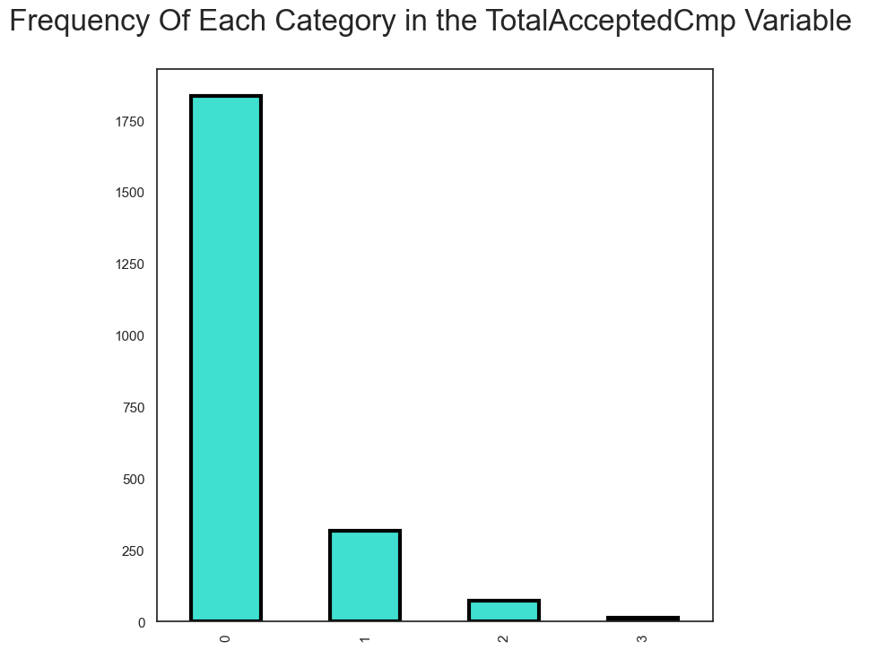

.

2

2. How Education Impacts on Expenses

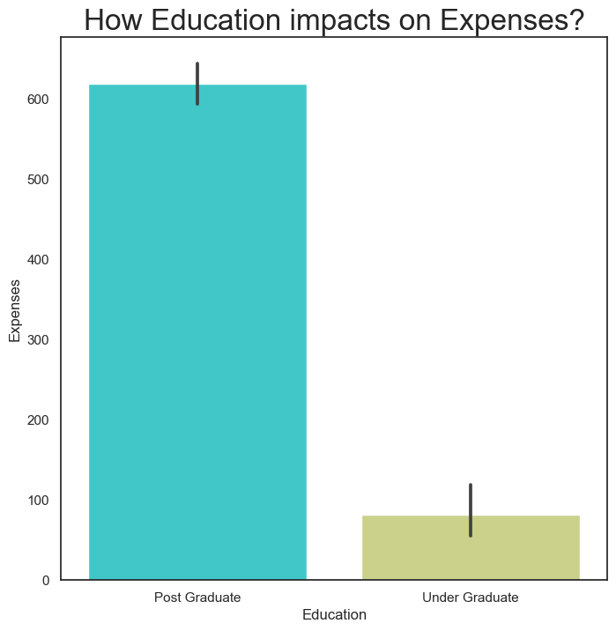

3.How Marital Status Impacts on Expenses

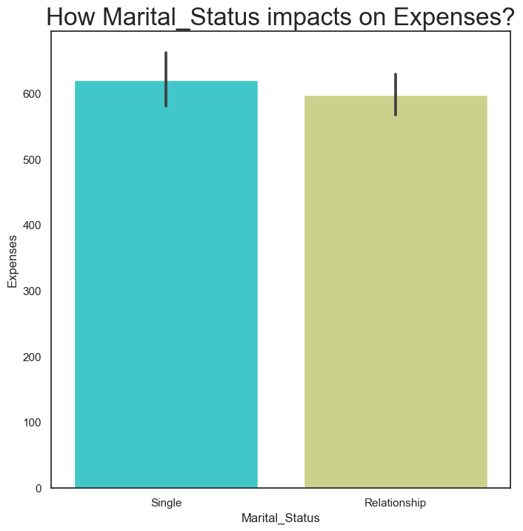

4. How Kids Impacts on Expenses

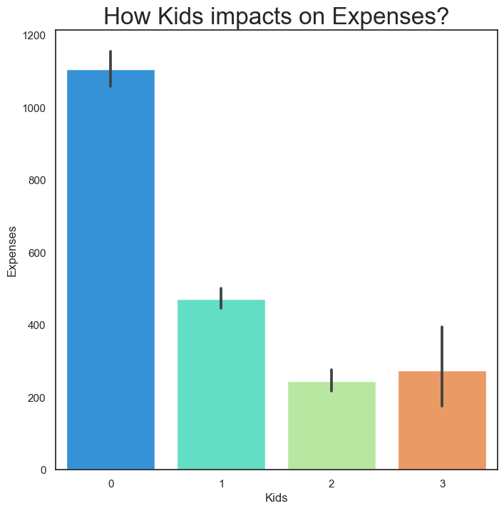

5. How TotalAcceptedCmp impacts on Expenses

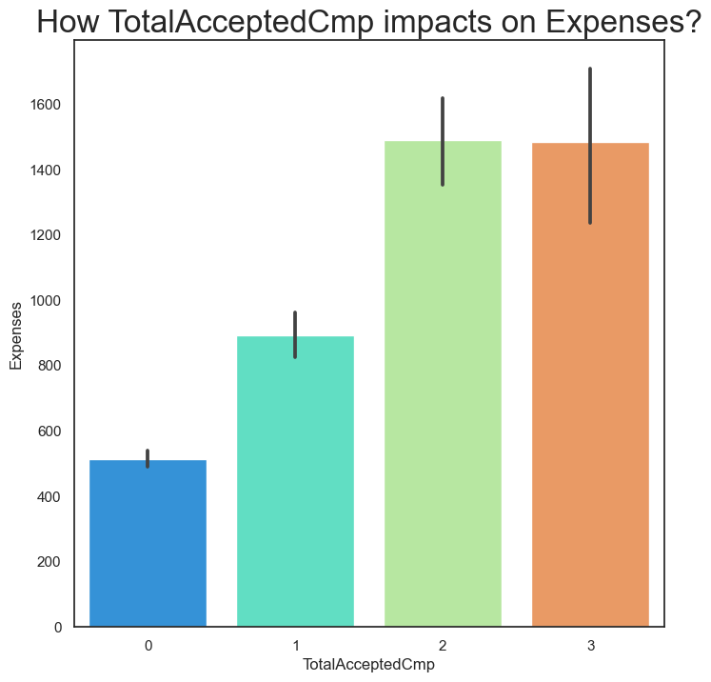

6. How NumTotalPurchase impacts on Expenses

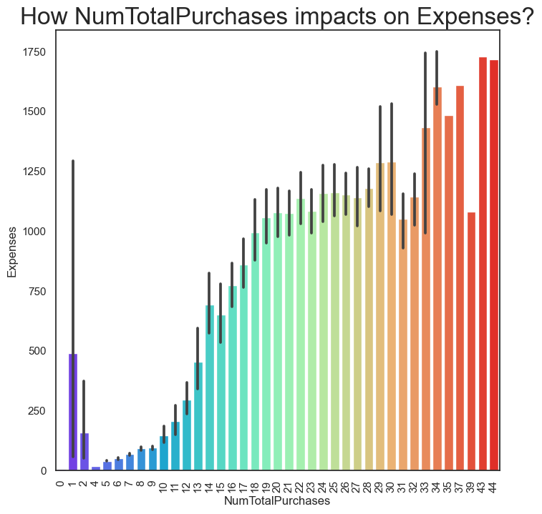

7. How Days Engaged Impacts on Expenses

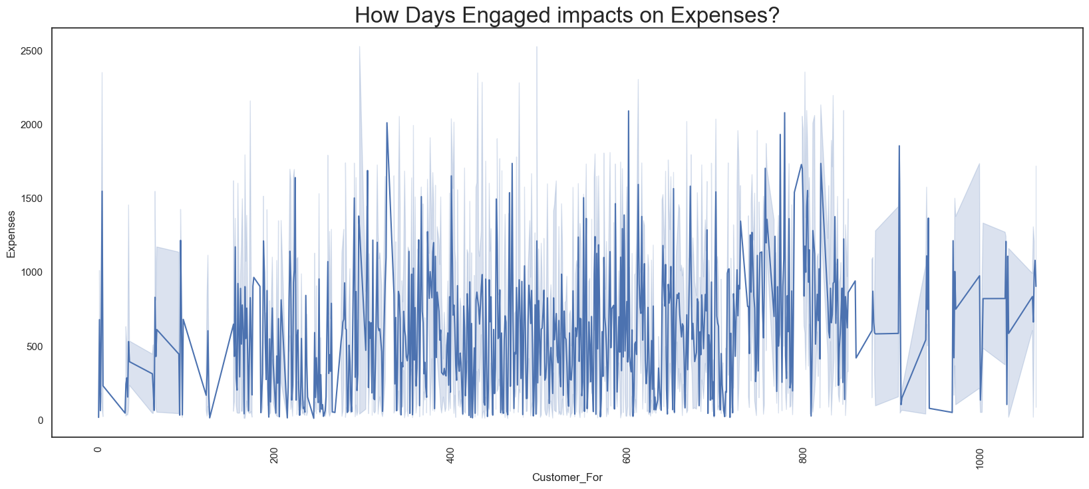

8. How Age Impacts on Expenses

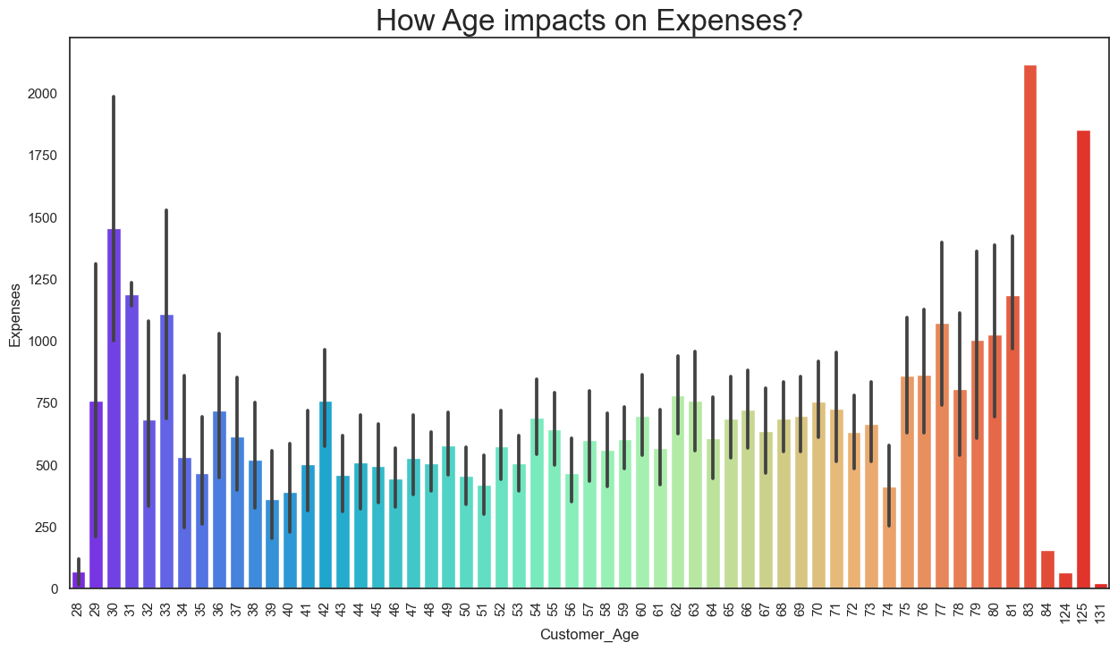

9. Finding the Correlation

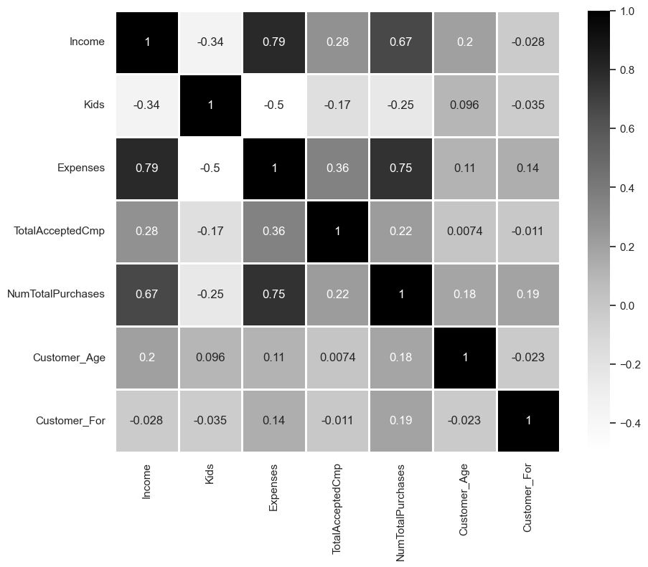

10. The Elbow Method

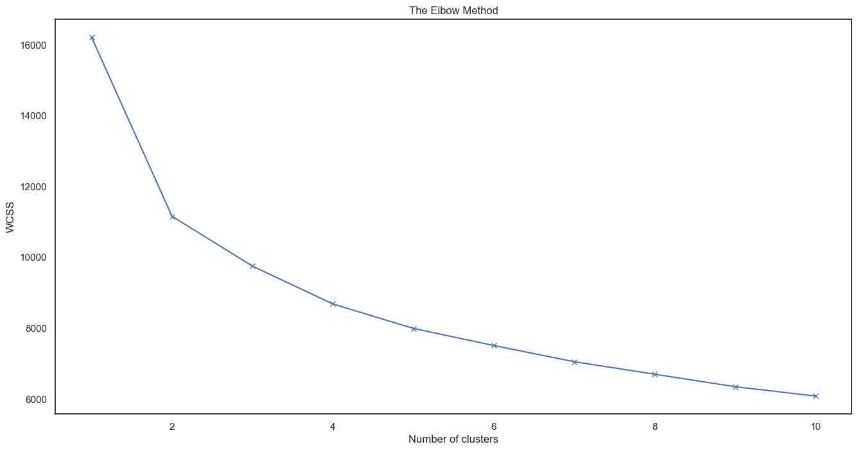

11. Scatterplot with Cluster Kmeans

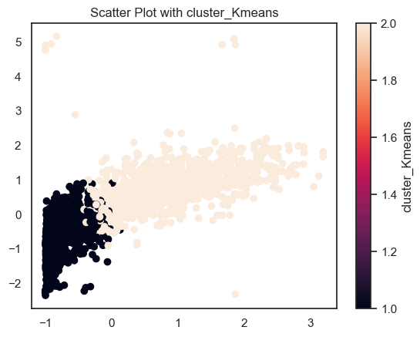

12. A 3-D Projection of Data in the Reduced Dimension

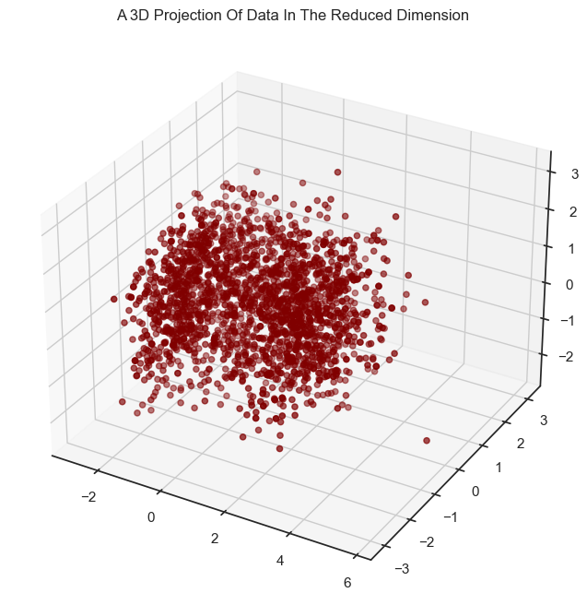

13. The Plot of Clusters

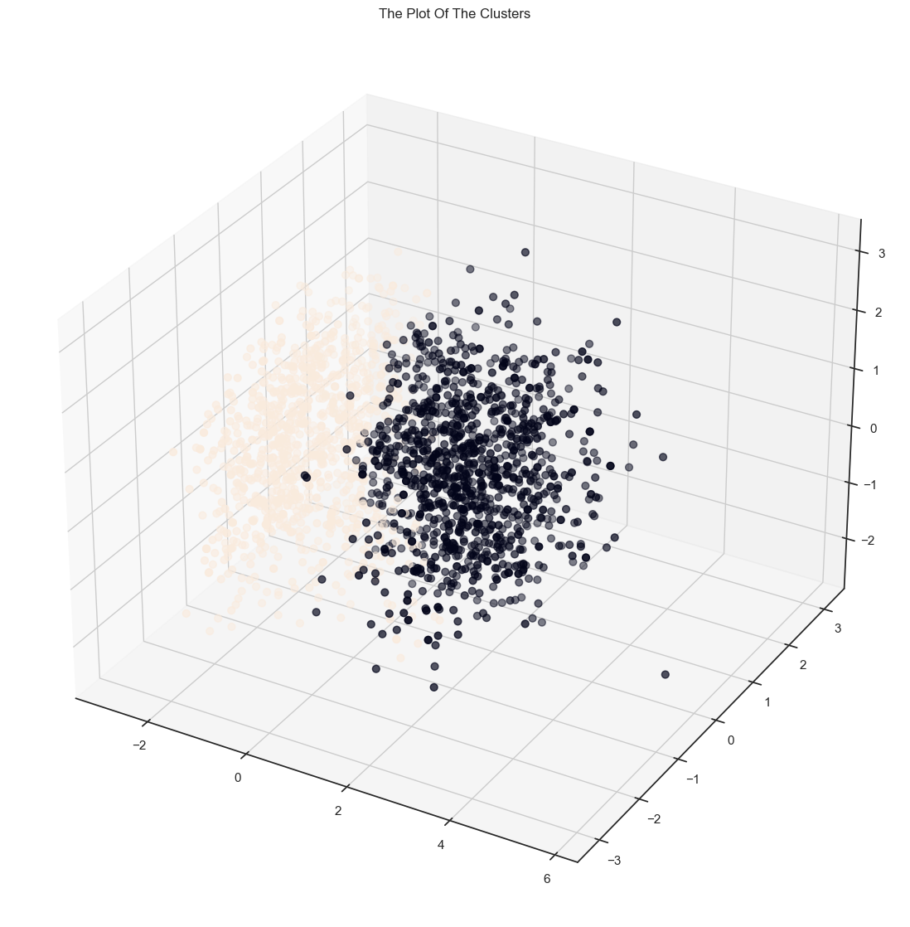

y

Cluster 1:

People with less expenses

people who are married and parents of more than 3 kids

people which low income

Cluster 2:

people with more expenses

people who are single or parents who have less than 3 kids

people with high income

Age is not the criteria but it is observed to some extent that people who are older fall in this group



Chapter 5

Standards Adopted

## Design Standards

.

1. Consistent Formatting: Maintain consistency in formatting throughout the report, including font style, size, and color, as well as alignment and spacing.

2. Clear Structure: Organize the report into sections such as Introduction, Methodology, Analysis, Results, Conclusion, and Recommendations to facilitate readability and comprehension.

3. Visual Elements: Incorporate visual elements such as charts, graphs, and tables to present data and findings in a visually appealing and understandable manner.

4. Accessibility: Ensure that the report is accessible to a diverse audience by using plain language, avoiding jargon, and providing explanations for technical terms or concepts.

5. Clarity and Conciseness: Clearly articulate key points, findings, and recommendations in a concise and straightforward manner to avoid ambiguity or confusion.

6. Data Integrity: Maintain the integrity of data presented in the report by accurately citing sources, providing context for data interpretation, and avoiding manipulation or selective reporting.

7. Credible Sources: Use reputable sources and references to support assertions, findings, and recommendations presented in the report, ensuring credibility and reliability.

8. Compliance: Adhere to relevant regulations, standards, and guidelines governing data privacy, confidentiality, and ethical considerations in data analysis and reporting.



## Coding Standards

1. Descriptive Naming: Use meaningful and descriptive names for variables, functions, and classes to enhance readability and maintainability of the code.

2. Consistent Formatting: Follow a consistent coding style throughout the project, adhering to conventions for indentation, spacing, and line length.

3. Modular Design: Organize code into modular components or functions that perform specific tasks, promoting code reusability and simplifying maintenance.

4. Error Handling: Implement robust error handling mechanisms to gracefully handle exceptions and errors, ensuring the reliability and robustness of the code.

5. Testing: Write unit tests to validate the functionality of individual components and integration tests to verify the interaction between different modules.

6. Version Control: Utilize version control systems such as Git to manage code changes, collaborate with team members, and track project history.

8. Optimization: Optimize code for performance and efficiency, avoiding unnecessary computations or redundant operations to improve execution speed and resource utilization.

## Testing Standard

1. Test Coverage: Aim for comprehensive test coverage, including unit tests, integration tests, and end-to-end tests, to verify the functionality and behavior of all components of the project.

2. Test Plan: Develop a test plan outlining the objectives, scope, resources, and schedule for testing activities, ensuring thorough and systematic testing of the project.

3. Test Cases: Create clear and detailed test cases for each feature, functionality, and edge case, specifying inputs, expected outputs, and preconditions for accurate testing.

4. Regression Testing: Conduct regular regression testing to ensure that new changes or updates do not introduce unintended side effects or regressions in existing functionality.

5. Performance Testing: Perform performance testing to evaluate the responsiveness, scalability, and stability of the project under various load conditions and usage scenarios.

6. Security Testing: Incorporate security testing to identify and mitigate potential vulnerabilities, such as input validation, authentication, authorization, and data encryption.

7. Usability Testing: Include usability testing to assess the user-friendliness, accessibility, and intuitiveness of the project interface and interactions from the perspective of end-users.





Chapter 6

Conclusion and Future Scope

## Conclusion

In conclusion, the Customer Behaviour Analysis project represents a significant endeavor aimed at empowering businesses to better understand and connect with their customers. Through the utilization of Python programming, advanced data analysis techniques, and adherence to design, coding, and testing standards, the project has successfully achieved its objectives of conducting comprehensive customer analysis and deriving actionable insights.

By delving into the nuances of customer data, the project has uncovered valuable insights into customer preferences, behaviors, and motivations. From segmentation and clustering to visualization and interpretation, the analysis has provided businesses with a deeper understanding of their customer base, enabling them to tailor products, services, and marketing strategies to better meet customer needs and drive strategic decision-making.

Throughout the project lifecycle, a commitment to rigorous testing standards has ensured the reliability, robustness, and quality of the software solution. By conducting thorough testing, including unit tests, integration tests, and performance tests, the project has mitigated risks, identified issues, and delivered a software solution that meets the highest standards of quality and usability.

Looking ahead, the insights and recommendations generated by the Customer Behaviour Analysis project will serve as a valuable resource for businesses seeking to foster stronger relationships with their customers and drive sustainable growth and success in the marketplace. By embracing a customer-centric approach and leveraging the power of data-driven insights, businesses can position themselves at the forefront of innovation and differentiation, ultimately achieving their goals and aspirations in today's competitive business landscape.

In summary, the Customer Behaviour Analysis project has not only provided businesses with valuable insights into their customers but has also demonstrated the potential of data-driven decision-making to drive meaningful outcomes and create lasting value for businesses and their customers alike.

## Future Scope

1. Enhanced Data Sources: Expand the project's scope by incorporating additional data sources such as social media data, CRM data, or transactional data to enrich the analysis and provide deeper insights into customer behavior.

2. Advanced Machine Learning Techniques: Explore advanced machine learning techniques such as natural language processing (NLP), deep learning, or reinforcement learning to uncover hidden patterns and trends in customer data and improve the accuracy of customer segmentation.

3. Real-time Analysis: Implement real-time data processing capabilities to enable continuous monitoring and analysis of customer behavior, allowing businesses to respond promptly to changing market conditions and customer preferences.

4. Personalization: Develop personalized recommendation systems or content personalization algorithms based on the insights derived from the analysis, enhancing the customer experience and driving engagement and loyalty.

5. Predictive Analytics: Utilize predictive analytics models to forecast future customer behavior, such as purchase propensity, churn prediction, or lifetime value prediction, enabling businesses to proactively address customer needs and mitigate risks.

6. Integration with Business Processes: Integrate the analysis findings with key business processes such as product development, marketing campaigns, and customer service initiatives to ensure alignment with organizational goals and objectives.



***References***

1. Segaran, Toby. "Programming Collective Intelligence: Building Smart Web 2.0 Applications." O'Reilly Media, 2007.
2. McKinney, Wes. "Python for Data Analysis: Data Wrangling with Pandas, NumPy, and IPython." O'Reilly Media, 2017.
3. Raschka, Sebastian, and Mirjalili, Mohammad. "Python Machine Learning: Machine Learning and Deep Learning with Python, scikit-learn, and TensorFlow." Packt Publishing, 2019.
4. Pedregosa, F., et al. "Scikit-learn: Machine Learning in Python." Journal of Machine Learning Research, vol. 12, 2011, pp. 2825-2830.
5. McKinsey & Company. "Customer segmentation: An Overview." [Online] Available: <https://www.mckinsey.com/business-functions/marketing-and-sales/our-insights/customer-segmentation-a-guide-to-the-best-practices>
6. Hastie, Trevor, Tibshirani, Robert, and Friedman, Jerome. "The Elements of Statistical Learning: Data Mining, Inference, and Prediction." Springer, 2009. [Book]
7. Van den Poel, Dirk. "Predicting Mail-Order Repeat Buying: Which Variables Matter?" Journal of Interactive Marketing, vol. 19, no. 3, 2005, pp. 69-82. [Paper]
8. Hastie, Trevor, Tibshirani, Robert, and Friedman, Jerome. "The Elements of Statistical Learning: Data Mining, Inference, and Prediction." Springer, 2009.
9. Chen, Kuan-Ching, et al. "Machine Learning Techniques for Customer Behaviour Analysis." IGI Global, 2020.
10. 1 McKinsey & Company. "Customer Segmentation and Targeting." [Online] Available: <https://www.mckinsey.com/business-functions/marketing-and-sales/our-insights/customer-segmentation-and-targeting> [Accessed: January 2022]

